How to Select Suitable Rubber Pads
How to Select the Suitable Rubber Pads?
Shapes & Sizes of the Pads
1. | Normally, we select the pads basing on the sizes of the printed pattern.
2. | If there are many fine lines, we use sharper and harder pads.
3. | Use bigger/softer/flater pads for bigger printed patterns.
4. | If there is combination of the patterns, use combinative pads.
5. | When pressing the pad to a certain level, the pressing angle is not good for
 | exhaustion. Therefore, do not choose too small pads when basing on printed size.
6. | When using harder pad, the pressing speed must exceed ink-floating speed.
 | Otherwise, the underflow-ink might occur.
7. | When the ink contains too many bubbles, a harder pad can sometimes discharge
 | the air out of the ink.
8. | When the printed area is curved, the deformation occurs
 | when you press the pad too fast.
Silicone Colors
1. | Generally, we use different colors to distinguish pads’materials.
2. | Find Cause Pads – Different colors for different pad characters.
Red: | High Hardness; Good Ink-Absorption;
 | Suitable for bad-exaust and etching patterns.
White: | Softer Pads; High-Ductility;
 | Used to cover irregular pattern and not easy to break.
Blue: | Good Anti-Solvent Resistance; Used for massive printing;
 | Enhance the life of the pads.

Hardness of the Pads
1. | Some silcone are soft and suitable fpr soft pads.
 | However, some silcone are only suitable for hard pads .
 | If making it into soft pads, it will reduce the life of the pads.
2. | Normally, the sharper/harder the pads are, the better exhaustion they are.
 | Therefore, we use sharper/harder pads for thinner lines and patterns.
3. | Hard pads are with better exhaustion but it is also easier to cause underflow-ink.
4. | For bigger area printing, use softer pads to avoid uneven shades.
5. | The harder the pads are, the greater that the pads can hold when printing.
Ink Absorption for Pads
1. | Better anti-solvent pads, the ink absorption is worse.
2. | Old pads’ ink absorption is better than new pads.
3. | Printing in advance to test the concentrated dilutions of the ink. If the evaporation
 | is ok but the pad still can't absorb the inks, use the cloth to clean up the pad.
4. | Clean the pad surface can enhance the ink absorption; however,
 | it can reduce its deinking as well.
5. | Try not to pause too long when sticking the ink. Do not stop the machine and
 | expose the content on the steel plate. These may cause the incompleted ink-sticking.
Deinking of the Pads
1. | The longer the pads are used, the deinking is worse because of the solvent
 | corrosion to the pads and friction between pads and printed objects.
2. | The faster the ink evaporating speed, the better the deinking is.
3. | When pressing the pad before touching the object, you can stop for 0.3-1.5
 | second (to make the ink a bit more dry) and then press down.
 | This is helpful for deinking. It especially works better using the dryer.
 | (Using dryer in winter helps the ink evaporation)
4. | The deinking effect is the best when the pad ink is at semi-dry state.
 | The deinking process can be done successfully more than 10,000 times per day.
Life of the Pads
1. | Normally, a pad can be used 10K – 50K times.
2. | Factors affecting the pad lives:
3. | A. Squeezing Variant
 | B. Solvent Corrosion
 | C. Oxidation
 | 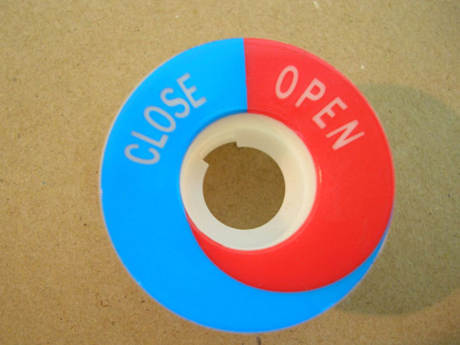
This product is suitable for softer/flater pad.
1. | FC-06 Pad; Red Silcone; Hardness: 20%.
2. | Ink: RUCO180 +30% Clear Coat
3. | Solvent: Fine Cause Extra Fast Evaporating Solvent
4. | Steel Plate Depth: 33u-36u
5. | Machine: FC-252 2-Color Pad-Printer
6. | Printed Object Material: Nylon
7. | Use dryer to assist deinking
8. | Stop before sticking ink: 0 second
 | Stop after sticking ink: 0.3 second
 | Stop before printing: 0.7 second
 | Stop after printing: 0.5 second

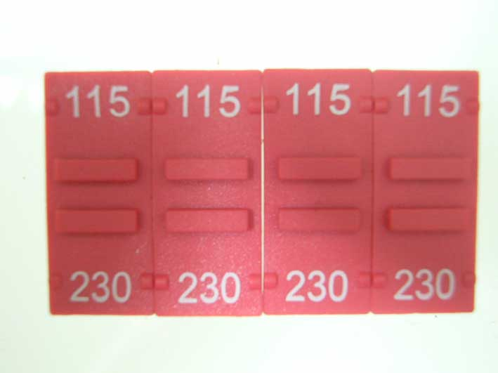
This product is suitable for sharper/harder pad.
1. | FC-120 Pad; Red Silcone; Hardness: 0%
2. | Ink: SEIKO-VIC Series
3. | Solvent: Fine Cause Extra Fast Evaporating Solvent
4. | Steel Plate Depth: 20u-22u
5. | Machine: FC-125 Single Color Pad-Printer + Auto Sliding Rail
6. | Printed Object Material: Nylon
7. | Use dryer to assist deinking
8. | Stop before sticking ink: 0 second
 | Stop after sticking ink: 0.3 second
 | Stop before printing: 0.3 second
 | Stop after printing: 0.3 second

